**Group 11**

Benjamin Arhen

Shafia Dudekula

**Project Title**

Creation of Online Games, Simulation Exercises, and/or Videos for Leadership & Psychology Experiments.

**Introduction**

Our project aims to provide a platform for researchers to carry out leadership and psychological experiments. The project offers a dynamic and engaging environment for users to take part in video simulations, online games, and training exercises that will be embedded in a website. The platform will allow researchers to plan and carry out studies that examine participants' reactions to various leadership and psychological challenges.

The project makes use of latest technology in react to create a user-friendly platform that is intuitive and offers a smooth experience for both participants and researchers. The platform will be available to researchers in academia and industry, making it a valuable tool for running experiments and generating insights by offering an effective and affordable solution. Our platform will help researchers conduct experiments that push the boundaries of traditional research methods.

**Design Glossary**

**Basic Research:** In psychology, research conducted for the sake of achieving a more detailed and accurate understanding of human behavior, without necessarily trying to address any particular problem.

**Consent Form:** A document informing participants of procedure, risks, and benefits of the research that is signed during the process of informed consent.

**Debriefing:** The process of informing research participants as soon as possible of the purpose of the study, revealing deception, and correcting misconceptions they may have as a result of participating in the study.

**Experiment:** A study in which the researcher manipulates the independent variable.

**Informed Consent:** Researchers obtain and document people’s agreement to participate in a study after having informed them of everything that might reasonably be expected to affect their decision.

**Random Assignment:** A method of controlling extraneous variables across conditions by using a random process to decide which participants will be tested in the different conditions.

**Variable:** A quantity or quality that varies across people or situations.

**Use Case Model**

In the use case diagram below, there are two primary actors: the researcher and the participant. The researcher can create, manage, and customize experiments through the system, while the participant can access experiments, participate in them, and submit responses.

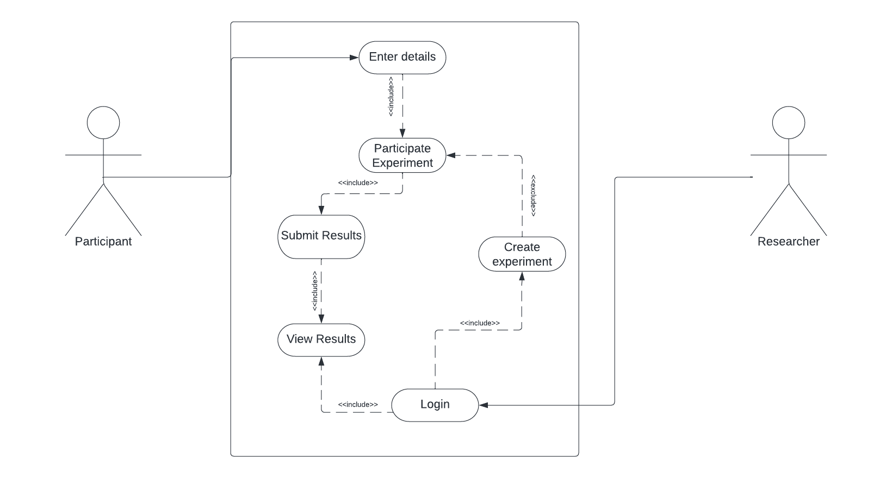

**Prototype**

Below are the two games involved in the experiment where the participants would take either as a team (cooperative manner), opponents (competitive manner) or as an individual experiment.

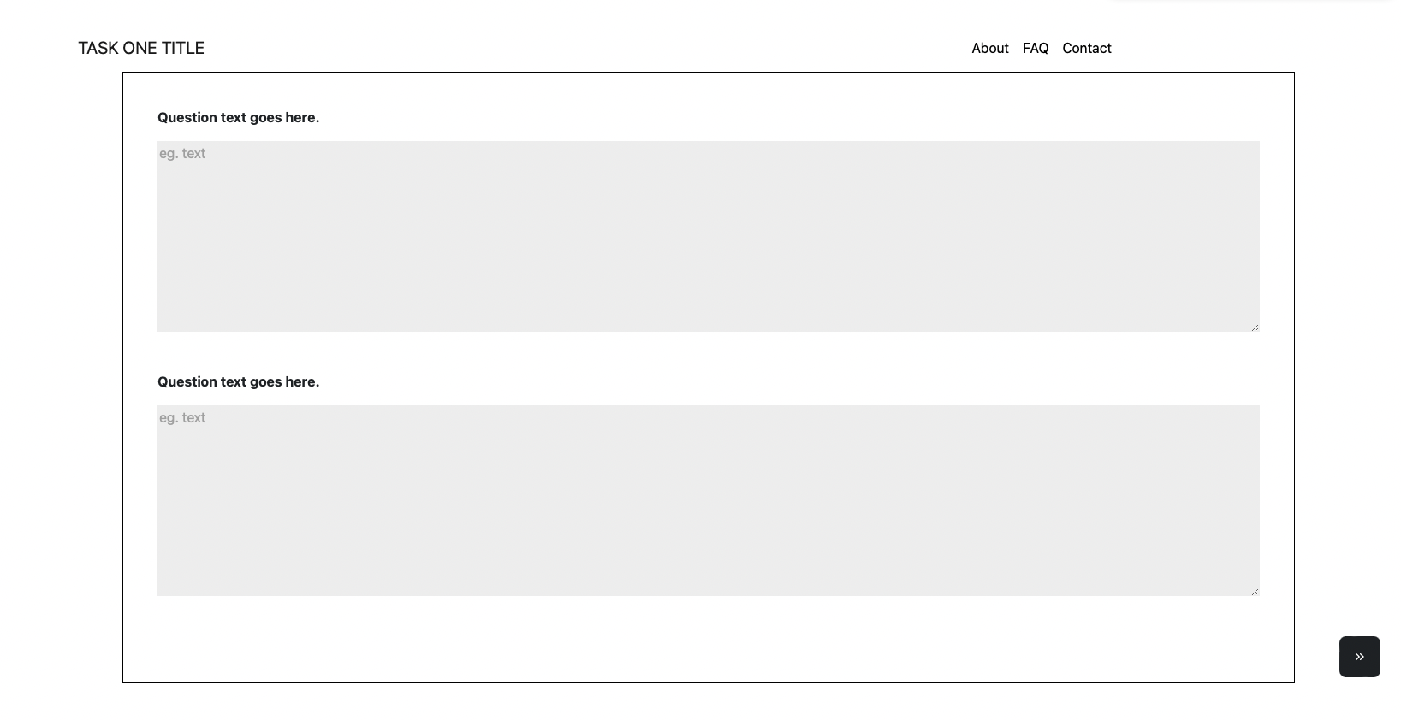

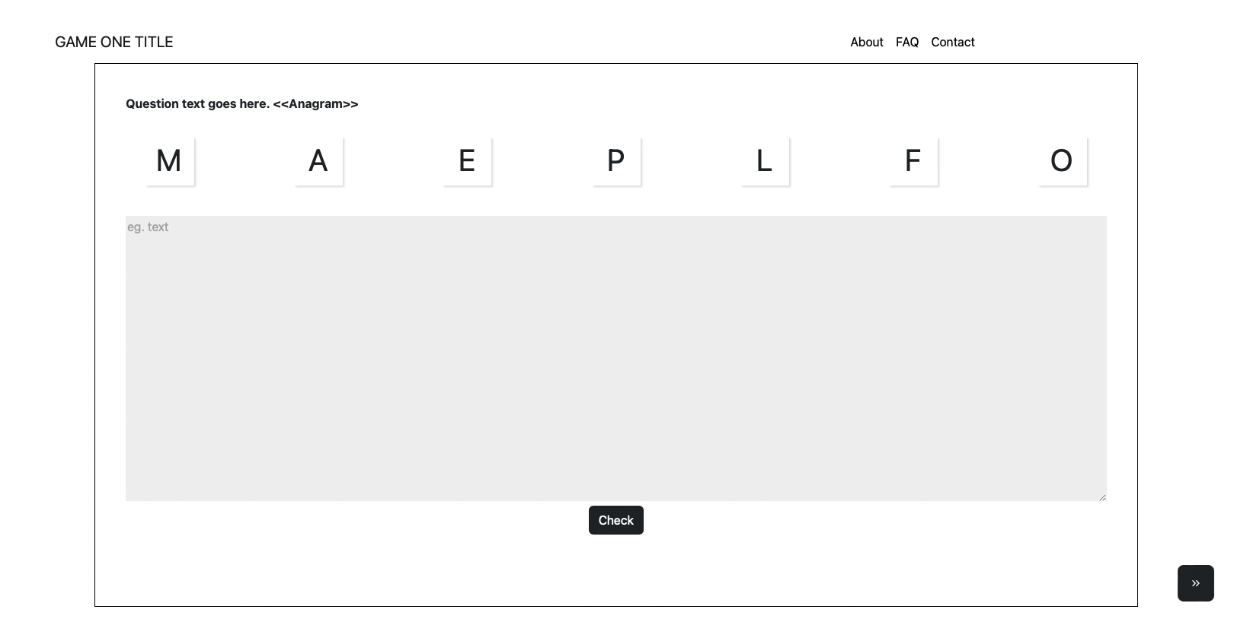

**Sprint Cycle 1**

For the first sprint there was not actual development work done as there was a bit of uncertainty about the modules of the project. Instead, we used this as opportunity to meet up with the client to clear up these uncertainties.

**Sprint Cycle 2**

In sprint 2, we designed and tested the game and questionnaire the user would be expected to answer.

Further testing would be done once we integrate the module, we are working on into the main module which the other team is working on.

**References**

Facebook. (2021). React documentation. Retrieved from <https://reactjs.org/docs/getting-started.html>

Qualtrics. (2021). Qualtrics XM Platform documentation. Retrieved from <https://www.qualtrics.com/support/>